

**Kennedy Baptist College**

**Semester One Examination 2018**

**Question/Answer Booklet**

**MATHEMATICS**

**METHODS UNIT 1**

**Section Two:**

**Calculator-assumed**

Student Name: _____________________________________

Teacher’s Name: _____________________________________

**Time allowed for this section**

Reading time before commencing work: ten minutes

Working time for paper: one hundred minutes

**Material required/recommended for this section**

**To be provided by the supervisor**

This Question/Answer booklet

Formula Sheet (retained from Section One)

**To be provided by the candidate**

Standard items: pens(blue/black preferred), pencils(including coloured), sharpener, correction tape/fluid, erasers, ruler, highlighters

Special Items: drawing instruments, templates, notes on two unfolded sheets of A4 paper, and up to three calculators approved for use in the WACE examinations.

**Important note to candidates**

No other items may be taken into the examination room. It is **your** responsibility to ensure that you do not have any unauthorised notes or other items of a non-personal nature in the examination room. If you have any unauthorised material with you, hand it to the supervisor **before** reading any further.

**Structure of this paper**

|  |  |  |  |  |  |
| --- | --- | --- | --- | --- | --- |
|  | Number of questions available | Number of questions to be attempted | Suggested working time (minutes) | Marks available | % |
| Section One  Calculator—free | 9 | 9 | 50 | 52 | 35 |
| **Section Two**  **Calculator—assumed** | **13** | **13** | **100** | **98** | **65** |
|  | | | | 150 | 100 |

**Instructions to candidates**

1. The rules for the conduct of Western Australian external examinations are detailed in the *Year 12 Information Handbook 2018.* Sitting this examination implies that you agree to abide by these rules.
2. Answer the questions according to the following instructions.

Section Two: Write answers in this Question/Answer Booklet. Answer **all** questions.

**Show all your working clearly.** Your working should be in sufficient detail to allow your

answers to be checked readily and for marks to be awarded for reasoning. Incorrect

answers given without supporting reasoning cannot be allocated any marks. For any

question or part question worth more than two marks, valid working or justification is required to receive full marks. If you repeat an answer to any question, ensure that you cancel the answer you do not wish to have marked.

It is recommended that you **do not use pencil**, except in diagrams.

1. You must be careful to confine your responses to the specific questions asked and to follow any instructions that are specific to a particular question.
2. Spare pages are included at the end of this booklet. They can be used for planning your responses and/or as additional space if required to continue an answer.

* Planning: If you use the spare pages for planning, indicate this clearly at the top of the page.
* Continuing an answer: If you need to use the space to continue an answer, indicate in the original answer space where the answer is continued, i.e. give the page number. Fill in the number of the question that you are continuing to answer at the top of the page.

1. The Formula Sheet is **not** handed in with your Question/Answer Booklet.

# Section Two: Calculator–assumed 65% (98 marks)

This section has **thirteen (13)** questions. Attempt **all** questions. Write your answers in the spaces provided.

Spare pages are included at the end of this booklet. They can be used for planning your responses and/or as additional space if required to continue an answer.

* Planning: If you use the spare pages for planning, indicate this clearly at the top of the page.
* Continuing an answer: If you need to use the space to continue an answer, indicate in the

original answer space where the answer is continued, i.e. give the page number. Fill in the

number of the question(s) that you are continuing to answer at the top of the page.

Working time: 100 minutes

**Question 10 (7 marks)**

The current A (amperes), varies inversely to the resistance R (ohms) in an electric circuit.

When the resistance is 12 ohms, the current is 0.5 amperes.

**(a)** State the constant of proportionality. (1 mark)

**(b)** Calculate the resistance if the current is 5 amperes. (1 mark)

**(c)** Determine the effect on R if A is increased by 35%. (2 marks)

**(d)** Draw the graph of this relationship. Label the axes. (3 marks)

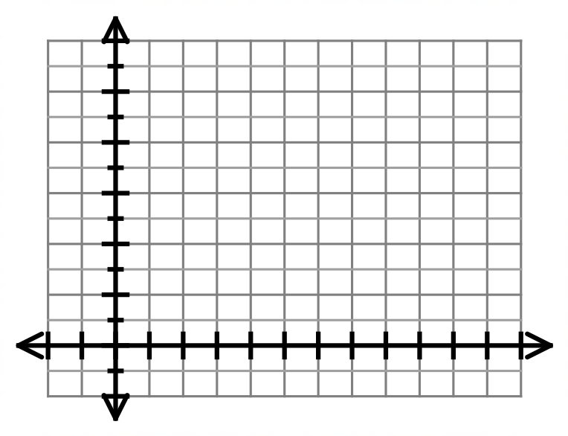

**Question 11 (12 marks)**

The depth, $x$ metres of a tidal river at a particular point on the river, $t$ hours after midnight on Sunday, is modelled by $x\left(t\right)=2cos\frac{πt}{6}+3, t≥0$. (Assume that midnight on Sunday corresponds to the end of Sunday).

1. Write down the minimum and maximum depth of the river for the above model. (2 marks)
2. What is the period of the graph in hours? (2 marks)
3. Draw a graph showing the depth of the river over a 24 hour period. Show clearly labelled axes and scales for both axes. (4 marks)

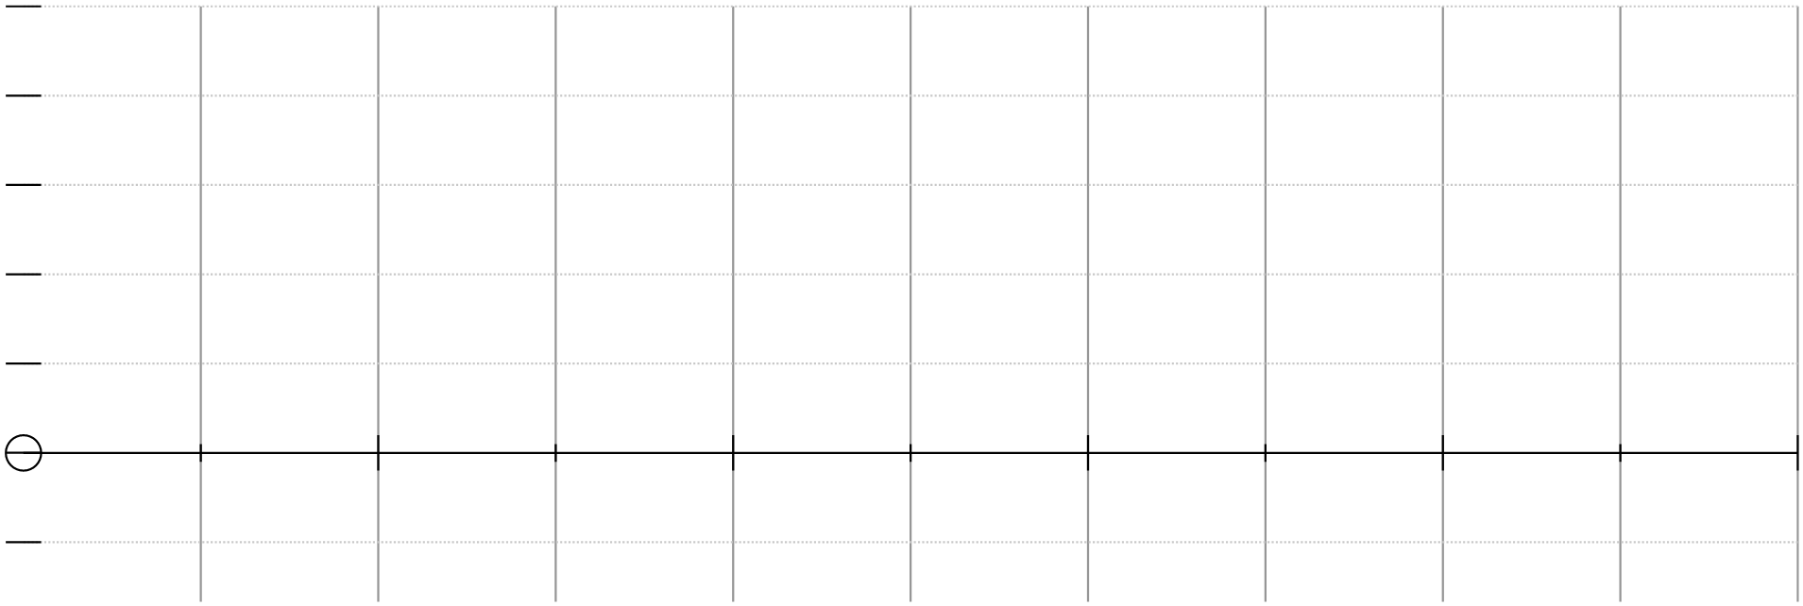

1. Find the depth, in metres, of the river at 5pm on Monday:
2. exactly
3. correct to 1 decimal place. (2 marks)
4. A ship needs a depth of at least 4m to sail sown the river. Find the times on Monday, when the ship can sail past this point. (2 marks)

**Question 12 (7 marks)**

A sector OPQ of a circle with centre O is drawn below. The radius of the circle is 18 cm and angle POQ is 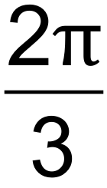 radians. The tangents to the circle at the points P and Q meet at point R. 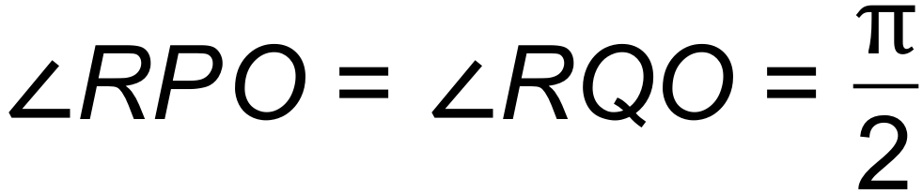

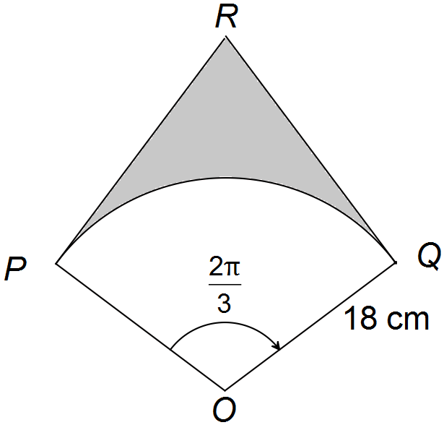

**(a)** Determine the exact length of arc PQ. (2 marks)

**(b)** Find the exact value in radians of 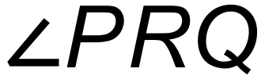. (1 mark)

**(c)** Find the exact area of the shaded region. (4 marks)

**Question 13 (7 marks)**

The circle with centre A(5, 8) touches the 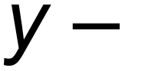axis as shown below.

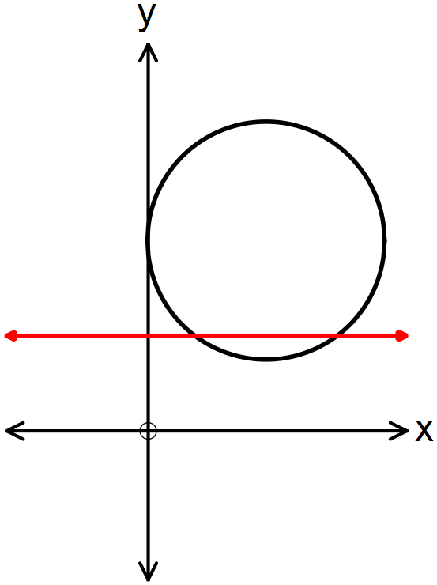

**(a)** Show clearly that the equation of the circle is 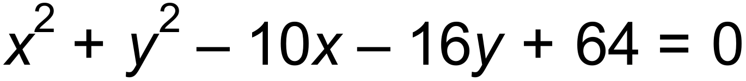. (2 marks)

**(b)** The line 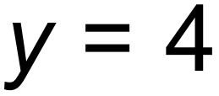 intersects the circle at point M and N.

(i) Determine the length of the chord MN. (2 marks)

(ii) Find the area of the minor segment formed between MN and the circle. (3 marks)

**Question 14 (7 marks)**

a) Determine the smallest positive solution to the equation $3\cos\left(3x\right)=1$, where $x$ is in degrees, giving your solution to three significant figures. (1 marks)

b) By using the expansion of $\cos{(A+B)}$ show that $\cos\left(2x\right)=2\cos^{2}x-1$ (2 marks)

c) Solve

1. $cos2x=0.7 for 0≤x≤360$ correct to 1 decimal place. (2 marks)
2. $\sin\left(\frac{x}{2}\right)=cos⁡(\frac{x}{2})$ for $0≤x≤4π$. Give your answer in exact form in radians. (2 marks)

**Question 15 (6 marks)**

Melissa is on her stand−up board and paddles from a buoy on a bearing of 016°T for 20 minutes at a speed of 4.2 km/hr. She then changes course and paddles on a bearing of 102°T for a further 430 m.

**(a)** How far is she from the buoy where she started? (3 marks)

(Draw a diagram.)

**(b)** What bearing must she take if she wishes to return directly to her starting position? (3 marks)

**Question 16 (9 marks)**

The point P(1,*k*) lies on the curve with equation 

(i) Find the value of *k.* (1 mark)

(ii) Express in a completely factorised form. (2 marks)

(iii) On the axes below sketch the curves with the following equations

and, showing clearly any intercepts. (3 marks)



(iv) Read from the graph the **number** of solutions to the equation:  (1mark)

(v) By adding **one** suitable function on the axes, show how you could solve  graphically.

Give the solution(s) from your graph, correct to 1 decimal place. (2 marks)

**Question 17 (6 marks)**

The diagram below has an arc, PQ, of a circle with centre O and radius r.

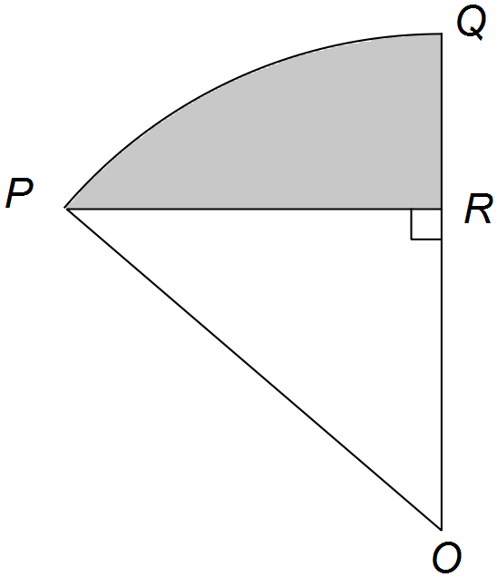PR is perpendicluar to OQ. Angle POQ = 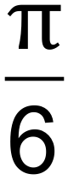 radians.

**(a)** Show that the area of triangle POR= 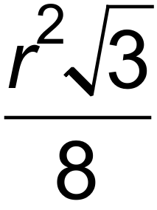 in terms of r. (Hint: First find expressions for OR and RR in terms of r) (3 marks)

**(b)** If the shaded area is 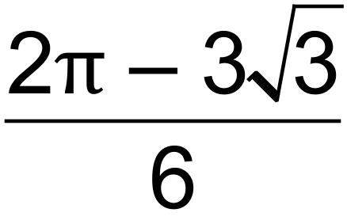 cm2, calculate the value of r. (3 marks)

**Question 18 (8 marks)**

The diagram shown is not drawn to scale. The lengths of AD and CD are the same. The length of AB is 10 cm.

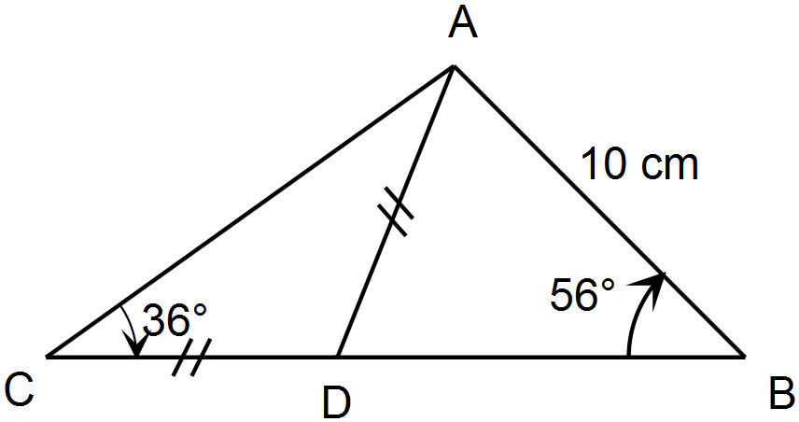

(a) If the lengths AC and AD, find *x* and *y* correct to 1 decimal place. (4 marks)

(b) Calculate the area of ΔABC. (2 marks)

(c) A line segment AE is drawn such that AE is perpendicular to BC. What is the length of AE?

(2 marks)

**Question 19 (8 marks)**

The graphs of eight functions are shown below.

A. B. C. D.

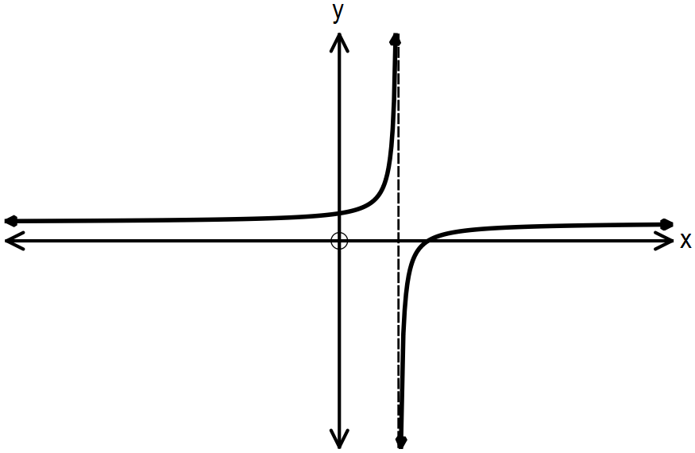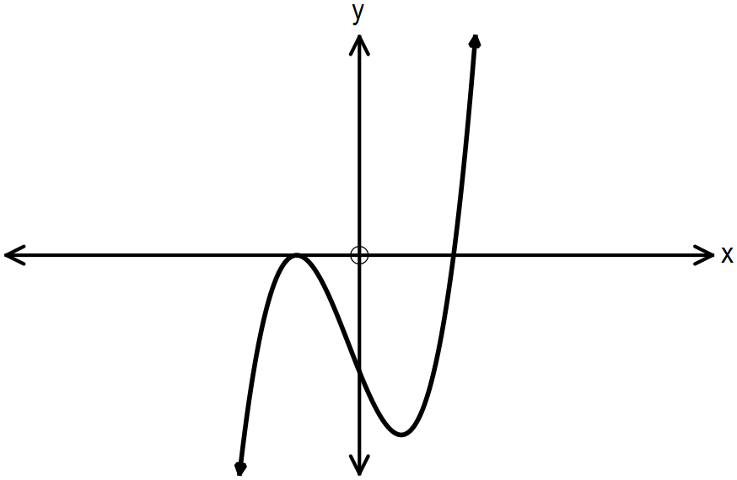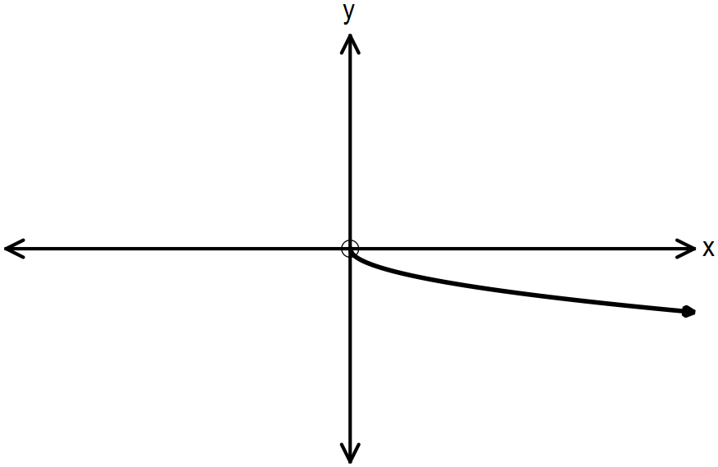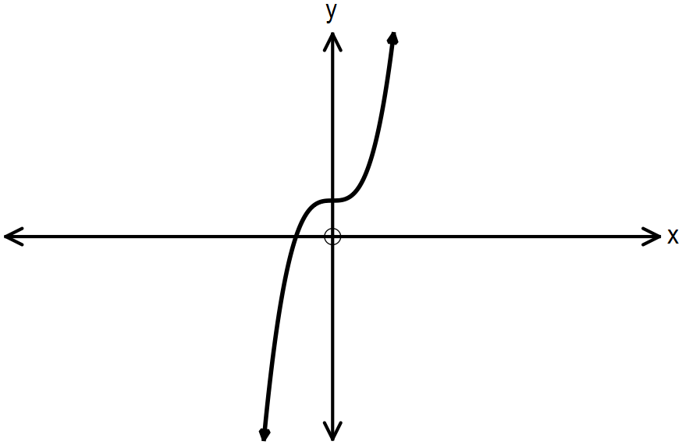

E. F. G. H.

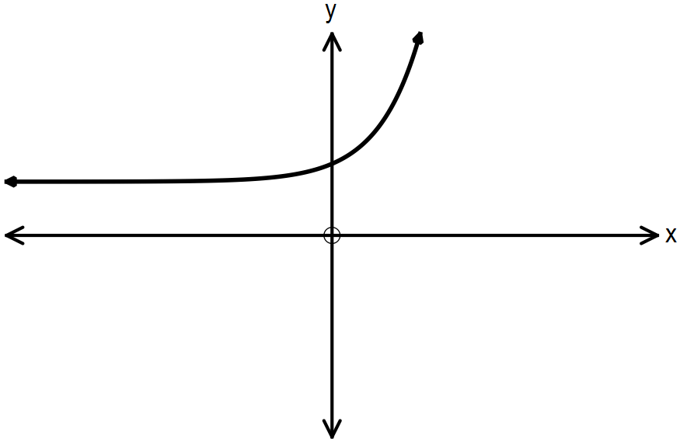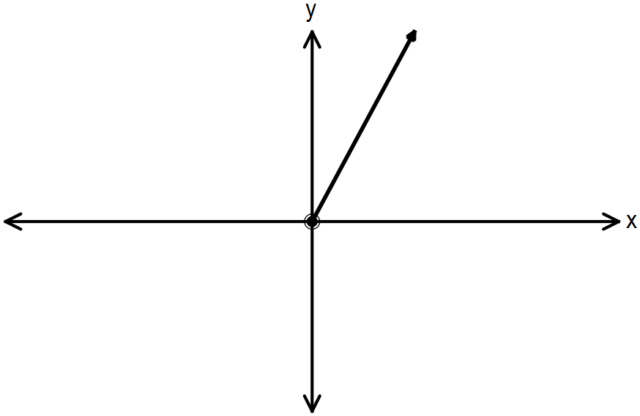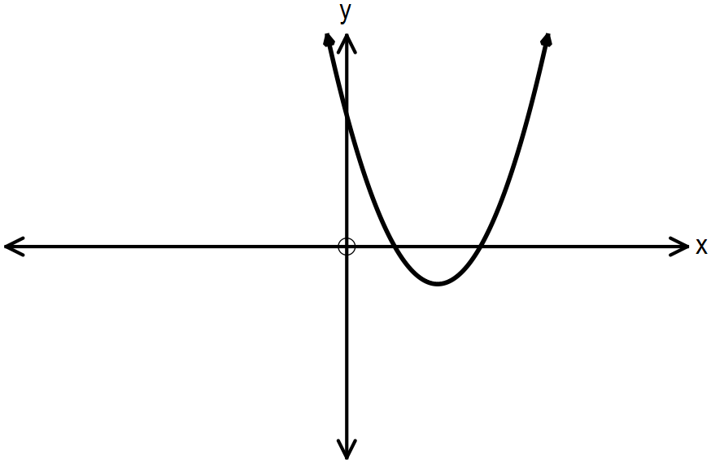

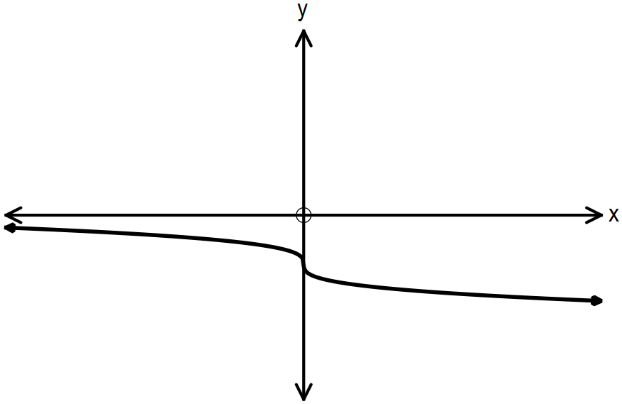

Identify the graph(s) that:

**(a)** has/have horizontal asymptotes. (1 mark)

**(b)** has/have only positive domains. (1 mark)

**(c)** has/have a positive constant gradient. (1 mark)

**(d)** represent(s) direct variance. (1mark)

**(e)** is/are in the form 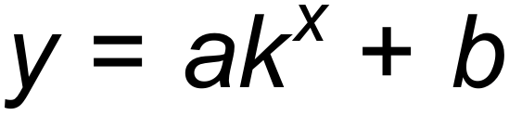. (1 mark)

**(f)** pass(es) through quadrants I, II and III only. (1 mark)

**(g)** has an axis of symmetry 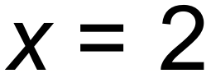. (1 mark)

**(h)** has/have a degree of 3. (1 mark)

**Question 20 (6 marks)**

The graph of the function  is shown below.



(a) State the equation(s) of all asymptote(s) of . (2 marks)

(b) Add the graph of  on the axes above. (2 marks)

(c) State the domain of . (1 mark)

(d) State the smallest positive solution to the equation . (1 mark)

**Question 21 (9 marks)**

**(a)** (i) The radius of a sphere is 15 cm. Determine the exact volume of the sphere. (1 mark)

(ii) The volume of a sphere is directly proportional to the cube of its radius. Using the information above in (i) show that the value of the constant of proportionality is 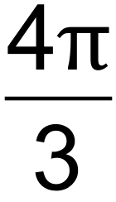 .

(1 mark)

(iii) Determine the angle of inclination between the graph of the direct variance function 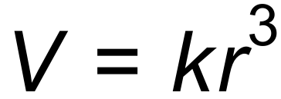 and the positive r3 – axis. (2 marks)

**(b)** The area of a rectangular room is 20m2. If the length is increased by 3m and the width is increased by 1m, the room will double in area. Formulate a quadratic equation, and hence determine the original dimensions of the room. (3 marks)

**(c)** State the domain and range of the function 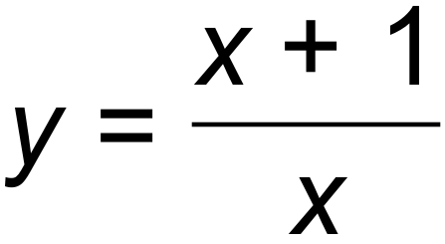. (2 marks)

**Question 22 (6 marks)**

Sound waves can be modelled on sinusoid functions. The following graphs were drawn after experiments with sound waves were conducted.

A: Quieter B: Louder

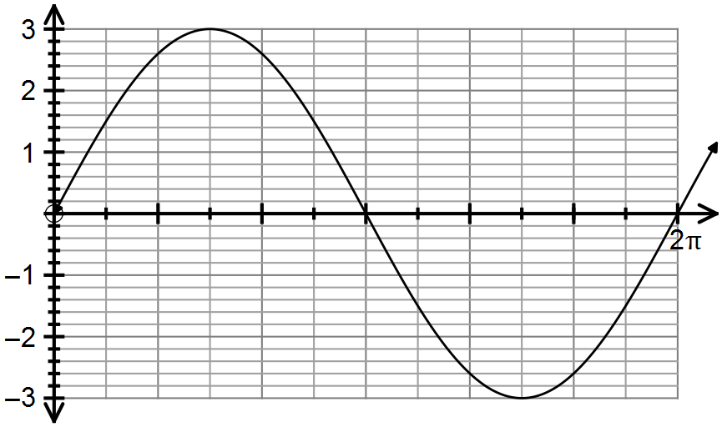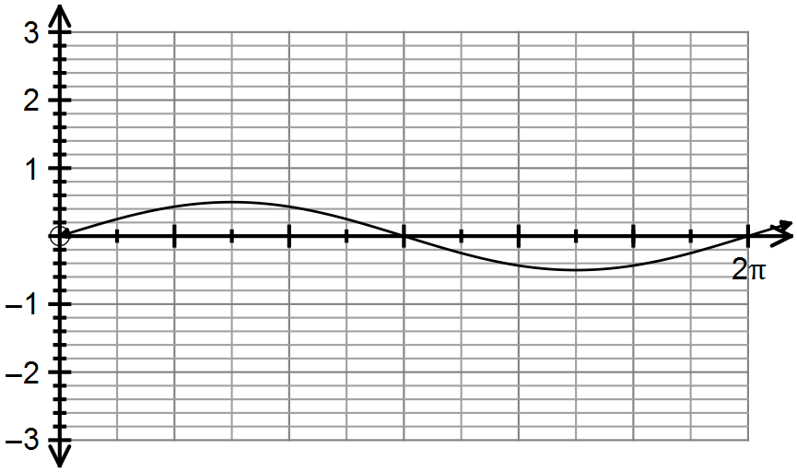

C: Deeper pitch D: Higher pitch

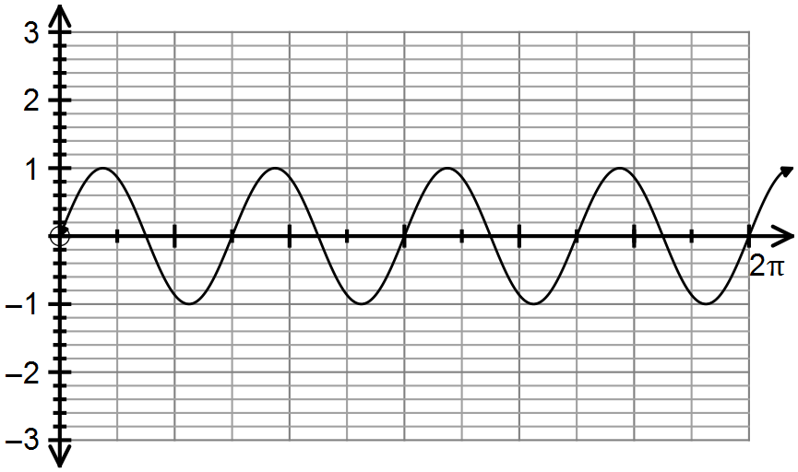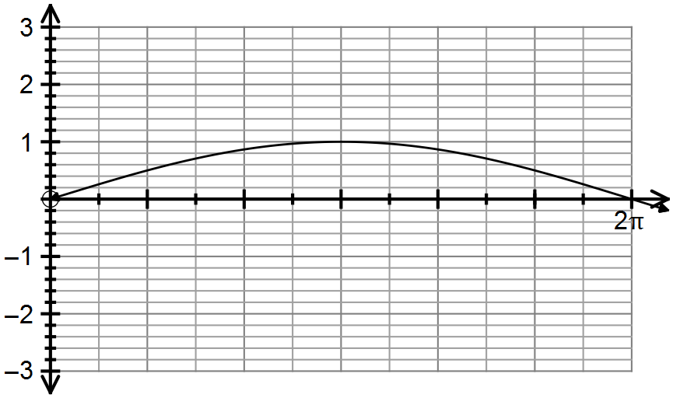

State the equation of each graph and discuss the changes in amplitude and period to achieve the different sounds.

**End of Questions**

**Additional working space**

Question number(s): ……………………

**Additional working space**

Question number(s): ……………………